Think Tank: Sleep

Curtis Kelly

When They Say “Get Eight hours of Sleep,” I Say, “Yeah, Right!”

Sleep deprivation hurts student performance. It interferes with learning. It can cause obesity, depression and bad driving. Okay, enough. I got it. But I am more worried about the effects of sleep deprivation on teacher performance, particularly, mine. I know I am not as sharp on days after short nights; I can hardly remember names. But worse, sleep deprivation is linked to Alzheimer’s, cardiac arrest, strokes and aging itself, things that will kill me.

"Sleep changes with aging, but it doesn't just change with aging; it can also start to explain aging itself," says review co-author Matthew Walker, who leads the Sleep and Neuroimaging Laboratory at the University of California, Berkeley. "Every one of the major diseases that are killing us in first-world nations--from diabetes to obesity to Alzheimer's disease to cancer--all of those things now have strong causal links to a lack of sleep. source

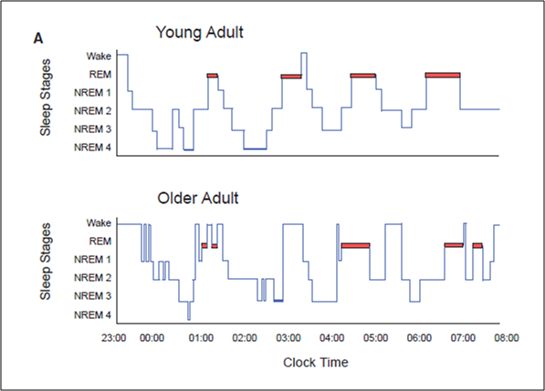
Damn. I find it hard to get more than 6 hours sleep a night. “So fix that! Even adults need 8” urge a barrage of podcasts and articles, but they don’t tell us how. I only get 6 hours of sleep a night because I cannot sleep more than that. Sleeping eight hours is physically impossible for me, no matter how hard I try. If I go to bed at 11, I wake up at 3:00. Sleep “deprived,” makes it that some person, me in this case, is making bad lifestyle choices, but that’s not right. It’s my own brain that’s doing the depriving. Worse, it’s not just mine. A large survey found that 30% of adults over 45 get less than six hours sleep most nights.
source
You see, sleep deteriorates with age. Some causes are snoring and apnea, certain medications, acid reflux, insomnia, but the biggest is just plain neural decline in the hypothalamus. As we age, the neural areas that regulate sleep, especially slow wave sleep, especially in men, deteriorate. Remember slow wave sleep? It is the phase new memories get written into the bigger book. So those “senior moments” might not represent brain deterioration as much as sleep deterioration.
“Get eight hours of sleep!” they say. I say, “Shut up!” and in quieter tones, “Mukatsuku.” Other than avoiding late day caffeine, there isn’t really anything we can do about the decline.
Or is there?
I might have found a couple holes in the rainclouds. One is, while showing chemical markers of sleep decline, “older adults rarely report feeling sleepy or sleep-deprived on surveys.” More than one researcher writes that off by claiming older adults are just used to sleep deprivation, but that kind of rationalization always sends up flags for me. Considering how plastic and adaptive the brain is, there might be more to it than just familiarity. There is a lot of research that shows sleep deprivation impedes cognitive function, but I wonder how much of it looks at the effects across age. Could it be that older brains handle sleep deprivation better?

So, I did my own net searches. I found a lot. You are more likely to have insomnia when you get older, there are still health issues associated with lack of sleep, but one National Institutes of Health study in particular caught my attention. After informing us that there are few studies examining the effects of total sleep deprivation on older adults, this one did, and they did it with both young and old subjects. They didn’t find differences in found performance loss, but fMRI data showed the older adults had more activation in brain regions associated with attention and inhibitory processes. In other words, the older adults were doing “compensatory recruitment of brain regions that aide in the maintenance of cognitive performance.” Could this be an early finding in discovering that all older brains compensate better for lack of sleep?
It makes sense. It is plasticity at work. But maybe more as well: In a recent Brain Science Podcast, Seth Grant reported his discovery that changes the way we see the brain. Brain aging is controlled by genes, which cause a predictable “lifespan calendar.” Age affects what proteins are present in synapses and how they perform, especially in relation to learning. Could those changes also make an older brain more efficient, thereby needing less sleep? Sleep is when learning happens, but older people probably do not need to spend as much time and energy learning as a five-year old because they have less to learn. In most cases, learning for us is just modification of what we already have. That would also explain why plasticity decreases with age. Preservation of these complex structures becomes more important. Maybe older people sleep less for reasons of efficiency.
Maybe older people sleep less for reasons of efficiency.

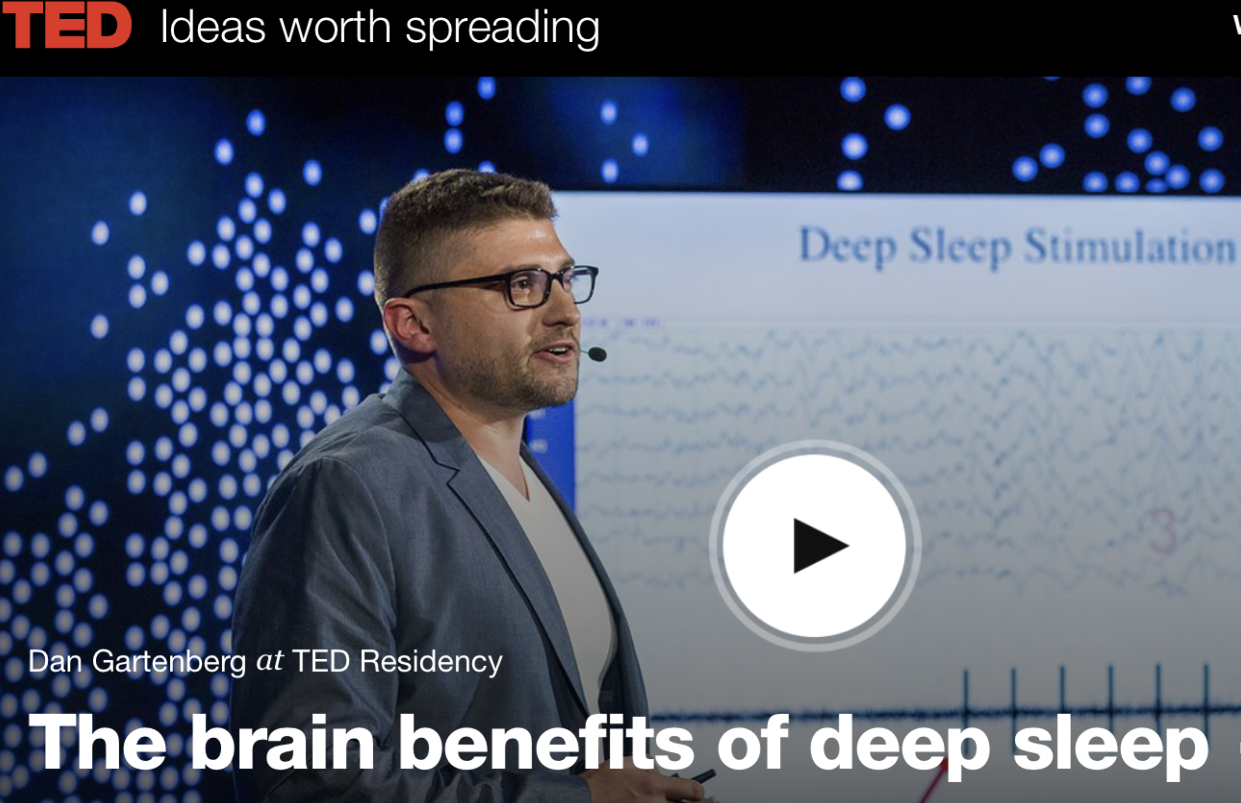
Then, a couple days ago, I found another possible hole in those dark clouds. I listened to a surprising TED TALK on deep sleep. Dan Gartenberg talks about his own struggles to get deep sleep and his failure using dozens of methods and devices. Then he met Dmitry Gerashchenko of Harvard Medical School who found that auditory input at the right time during sleep might induce longer periods of slow wave sleep. The sounds are not ocean waves, but rather something that sounds like radio static, but help stimulate the slow wave patterns that control deep sleep. Could this be the way for us to enhance sleep? Will this be the way for f us to extend our brainspan so that it lasts as long as our lifespan? I desperately hope so.
Well, get this: Gartenberg says he has developed a device that determines when you are entering deep sleep and then plays those sounds to augment that stage. It requires a fairly high-level computer, commonly known as…. the iPhone. There is an app for it and I just bought it for ¥120 on the App Store (you have to go there via your phone, not computer). If I look younger and healthier the next time we meet, you will know why. If not, it’s probably because I haven’t figured out how to use it yet. After all, I’m old.
In fact, we are in a trend of investigations into using sensory input to modify and even heal the brain. Doidge’s recent book, The Brains’ Way of Healing, discusses many. Or listen to Joy Hirsch talk about her experimentation with gamma wave input, through light not sound, to reduce amyloids in the brain, the main cause of Alzheimer’s. Interestingly, when Robert Murphy and I went to a conference in Boston, I got a chance to talk to her. I did not know her research was going in a direction that might be a life-saver for us older folks.
So sleep. I sometimes feel I am at war with my body, who steals more and more of my sleep away, but Gerashchenko’s work with using sound to augment slow wave sleep might be my Stalingrad.

Curtis Kelly (EDD), the first coordinator of the JALT Mind, Brain, and Education SIG, is a professor of English at Kansai University in Japan. He has written about 30 books, 100 articles, and given around 400 presentations.

